ARQUITECTURA DE CLASES

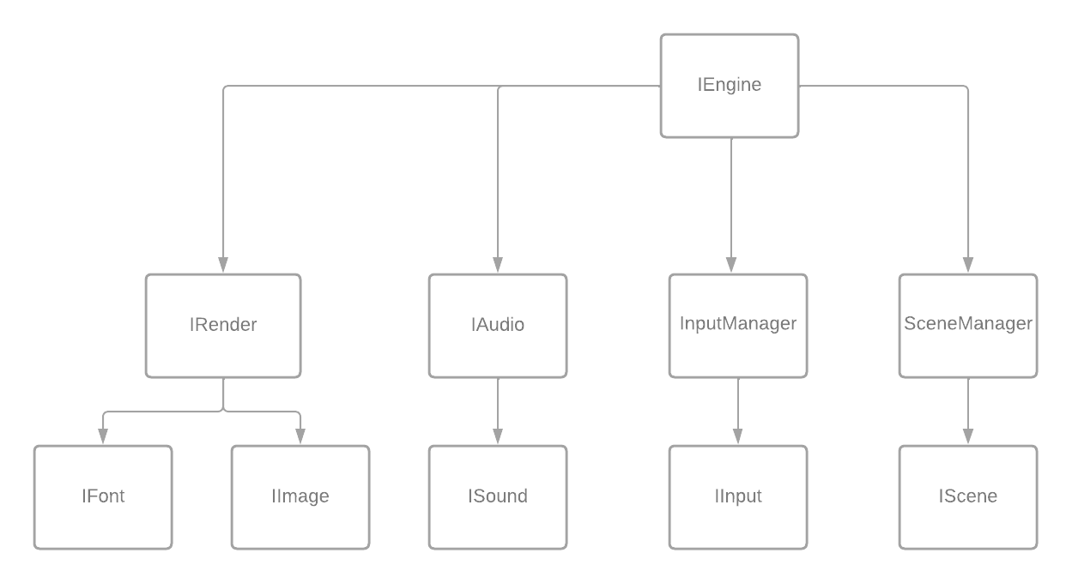

IEngine:

* IRender getRender()
* IAudio getAudio()
* SceneManager getSceneManager()
* InputManager getInputManager()

IRender:

* String loadImage(…)
* String loadFont(…)
* void setColor(int color)
* void setFont(String fontId)
* void drawLine(…)
* void drawRectangle(…)
* void drawCircle(…)
* void drawImage(…)
* void drawtext(…)
* int getWidth()
* int getHeight()
* int getTextWidth(String fontId, String text)
* int getTextHeight(String fontId)

IFont:

* int getSize()
* boolean isBold()
* boolean isItalic()

IImage:

* int getWidth()
* int getHeight()

ISound:

* float getVolume()
* void setVolume(float volume)

IAudio:

* void loadMusic(String filePath, float volume)
* String loadSound(String filePath, float volume)
* void playMusic()
* void playSound(String soundName)
* void setMusicVolume(float volume)
* void setSoundVolume(String soundName, float volume)

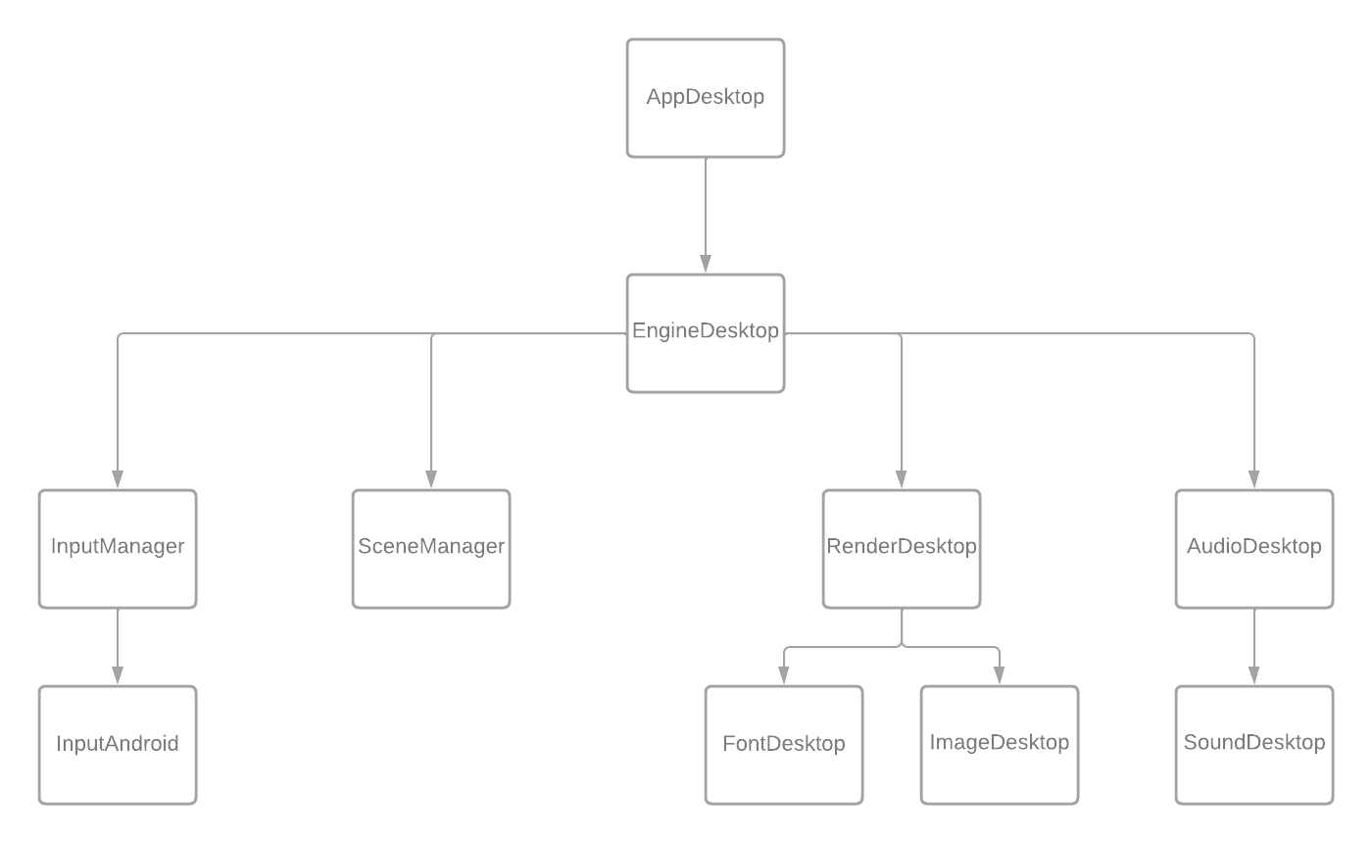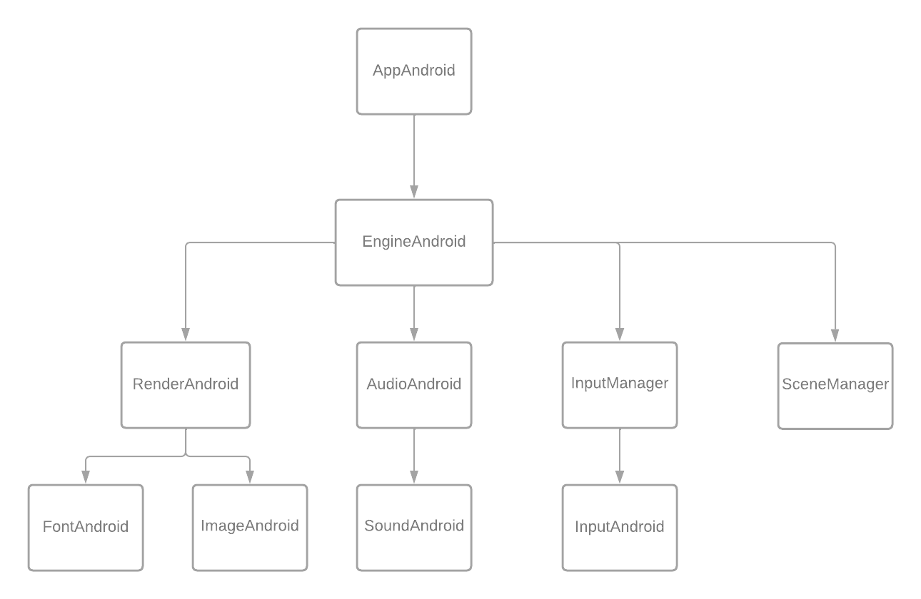

IInput:

* int getX()
* int getY()
* InputType getType()
* int getId()

InputManager:

* void addInput(IInput newInput)
* LinkedList<IInput> getInput()

SceneManager:

* IScene currentScene
* Void pushScene (IScene)
* IScene popScene()
* void update()
* void render(IRender render)
* void handleInput()

MODULOS:

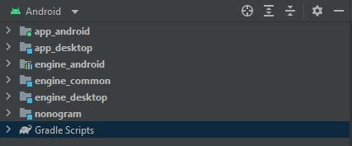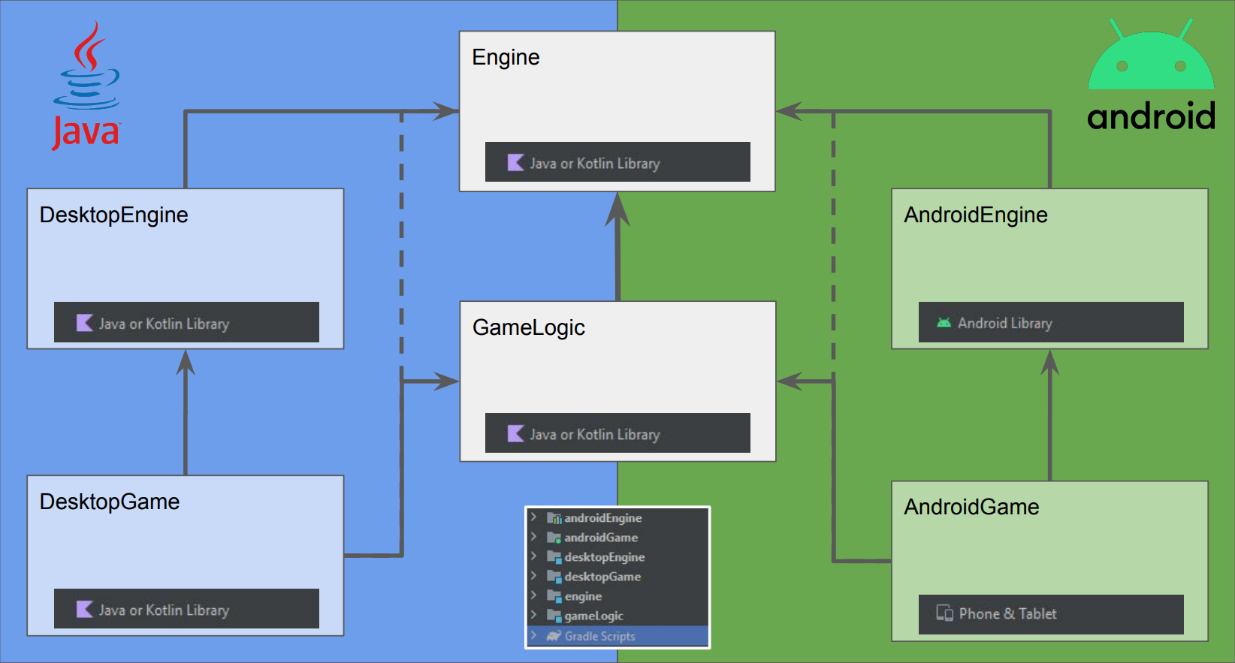

engine_desktop

engine_android

app_desktop

nonogram

engine_common

app_android

EXTRAS: